Booking a room in Microsoft Outlook - Windows
To book a room, the room is added to a meeting invitation.
- Open the Outlook app.
- Under the Meeting tab, select Appointment window.
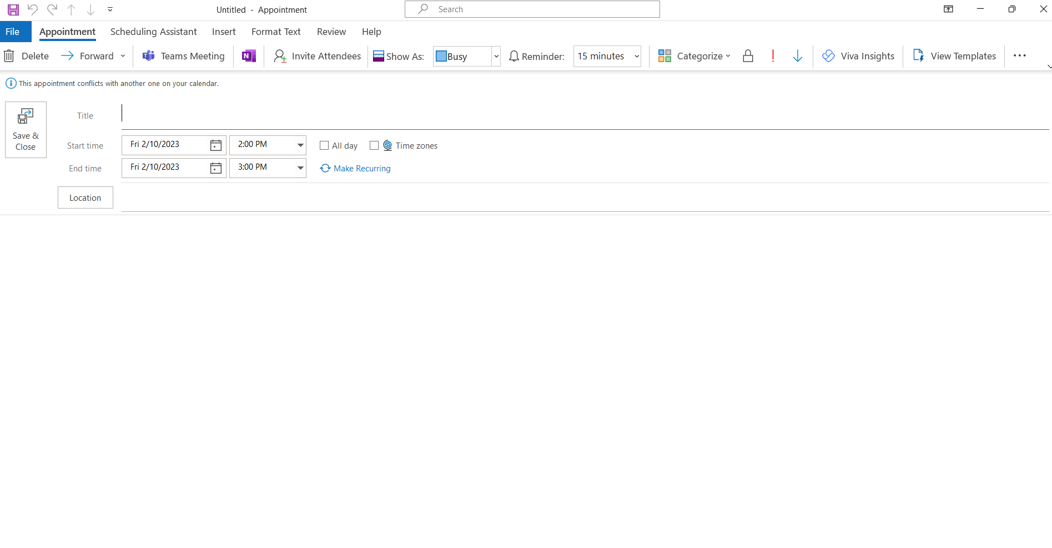

- Once the appointment window opens give the title of your meeting and then click location and select room finder option.

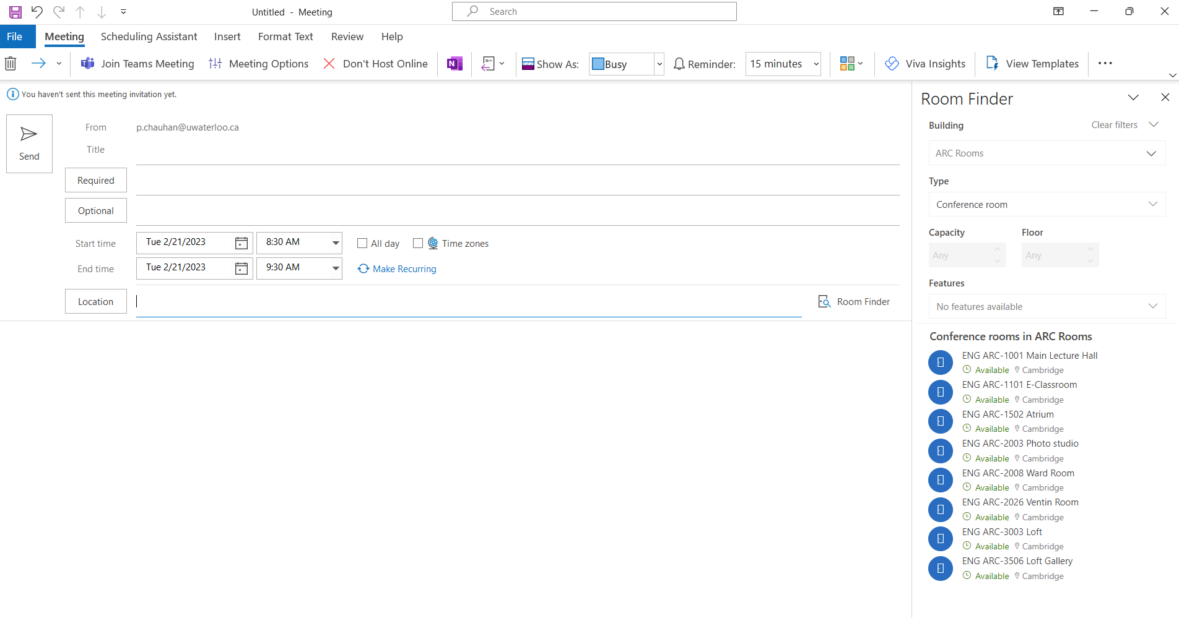

- Filter the room list by selecting city “Cambridge.”

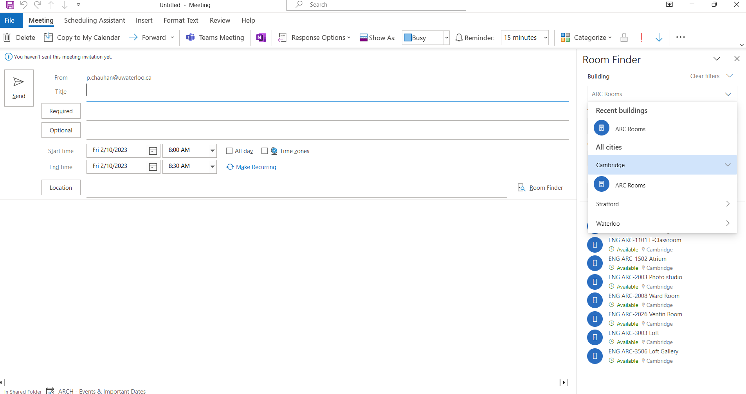

- Double-click the room to add it and click OK, if possible, please mention reason for your booking request.

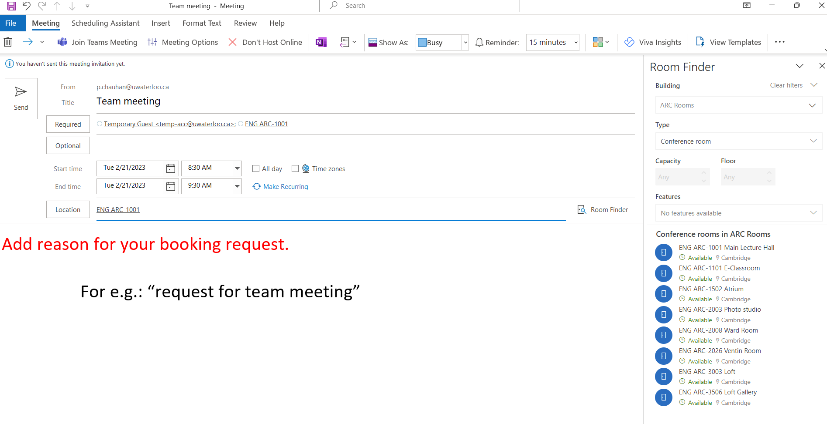

- Your booking request will go to “Administrative Assistance” to approve.
Note: Room requests will be approved or declined based on priorities.

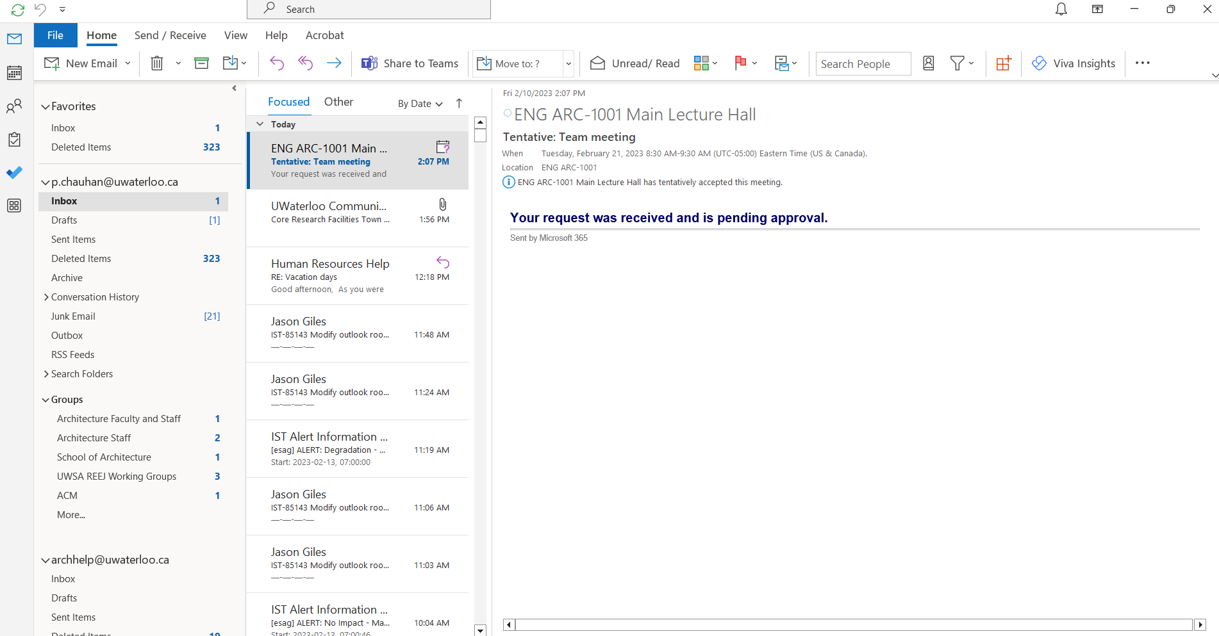

- You will receive email confirmation once the request is approved.

