**Start**

**Is it magnetic*?**

**Yes (#2) No (#4)**



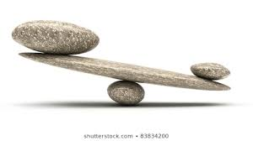

**#2**

**Is it heavier than other rocks?**

**Yes (#3) No (#5)**

**#3**

**Sand a side. Is the inside shiny like steel?**

**Yes (#10) No (#11)**

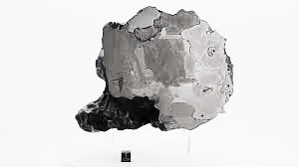



**#4**

**Is it heavier than other rocks?**

**Yes (#11) No (#7)**

**#5**

**Does it have a dark, thin crust on the outside?**

**Yes (#6) No (#11)**

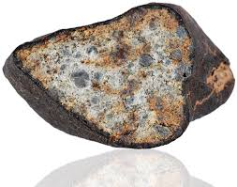

**#6**

**Does inside have particles with silver luster* or red spots?**

**Yes (#8) No (#11)**

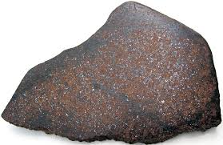

**#7**

**Does it have a dark, thin crust on the outside?**

**Yes (#9) No (#11)**



**#8**

**Does it have Regmaglypts*?**

**Yes (#12) No (#11)**

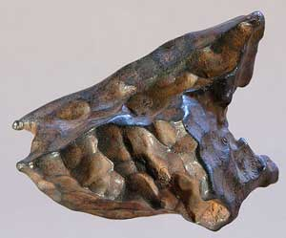

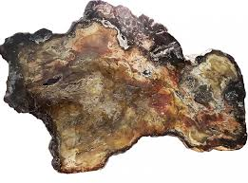

**#9**

**Is the inside lighter coloured than the outside?**

**Yes (#12) No (#11)**

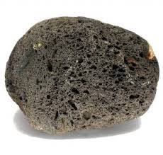

**#10**

**Does it have holes or bubbles inside?**

**Yes (#11) No (#8)**

**#11**

**Sorry, it is not a Meteorite**



**#12**

**Please send a photo of your rock to earthmuseum@uwaterloo.ca**

