New Possibilities for Meaningful Leisure Experiences
institutional, Medical model | Community, relational model
Level of Individual Experience (including individual experience of recreation professionals, doctors, nurses, Mrs. Jones, Mr. Smith, etc.) | Level of Individual Experience (including individual experience of recreation professionals, doctors, nurses, Mrs. Jones, Mr. Smith, etc.)
Staff provide traditional care and “treatments”  Separation of body and mind with primary focus on physical care  Patients/clients follow facility/organisation and staff routine  Staff have authority and make decisions for patients/clients  Staff have rotating assignments  Staff provide structured activities to patients/clients  Staff know patients/clients by diagnosis (e.g., bipolar, dementia, etc.)  Staff encouraged to be emotionally neutral | Individualized, person-centred care and support  Focus on holistic wellness where the human spirit is nurtured  Staff follow the individual’s routine and life rhythms  Individuals have meaningful choices and make their own decisions  Individual supported by familiar staff  Spontaneous activities around the clock for all  Staff know the person  Staff have personal relationships with the individual and their family
Organizational or Institutional Level | Organizational or Institutional Level
Departmental focus  Focus on care  Scheduled routines  Staff rotate among different floors, programs and patients/clients  Staff make decisions for patients/clients  Environment=workplace  Structured activities  Hierarchical departments  Staff care for patients/clients  Us and them, or us versus them  Individualism | Team focus  Focus on living life  Flexible routines  Staff assist same individuals  Decisions are made with individuals  Environment = home  Planned, flexible and spontaneous activities  Collaborative interdisciplinary teams formed from staff and individuals  Staff work in partnership with individuals  Mutual relationships  Emphasis on community
(Table adapted from Fagan, 2003)

Living and Celebrating Life through Leisure  Meaningful Leisure Experiences | Being Me: Leisure is a space for expressing the self, for simply being, and includes experiences that are personally meaningful and connected with current and/or past interests.
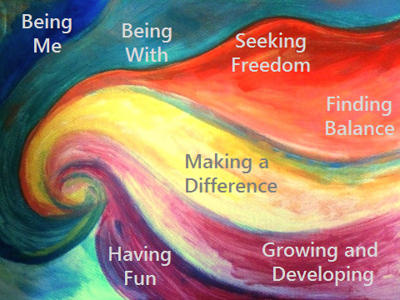
What Will You Do?

In order to support the meaningful leisure experiences of those with whom I work, I plan to…
 | Being With: Leisure provides a space for being with others, for experiences of a social nature. Opportunities that foster a sense of connection and community with others are highly valued.
 | Seeking Freedom: Leisure provides a much needed “break from the norm.” Some see leisure as an opportunity to “escape” the stress of daily tasks and responsibilities. Others see leisure as an opportunity to “get out” of environments that are socially and physically restrictive or as a freedom from day-to-day routines. Sometimes this is as simple as going for a walk.
 | Finding Balance: Leisure relates with the need to find the balance between “relaxation” and “keeping busy.” Too much of either is not a good thing and opportunities to feel contentment and at peace are important.
 | Making a Difference: Leisure provides experiences that fulfil a sense of purpose, provide opportunities to contribute, and enable one to feel helpful and valued.
 | Growing and Developing: Leisure provides an opportunity to continue to grow and develop by challenging the mind and the body and learning new things.
 | Having Fun: Leisure experiences are associated with feelings of pleasure, enjoyment, happiness, playfulness, mischievousness, and having a sense of humour.

