Booking a room in Microsoft Outlook – Apple Mac
To book a room, the room is added to a meeting invitation.
- Open the Outlook app.
- Open calendar tab, select Event option.

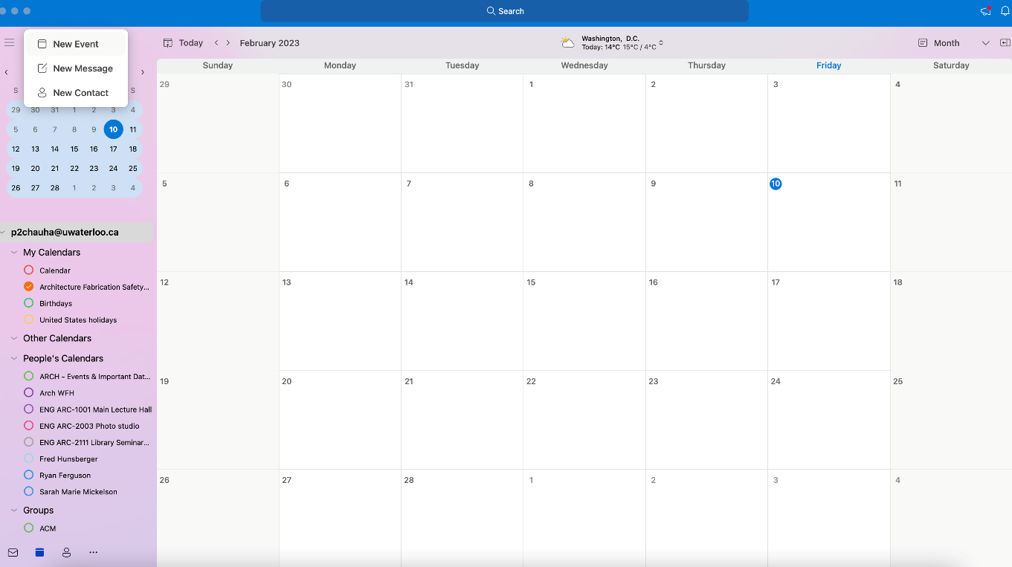

- Once the event window opens, give title of your event and click on “location” option Then click on “browse with room finder” option, to view the list of rooms.
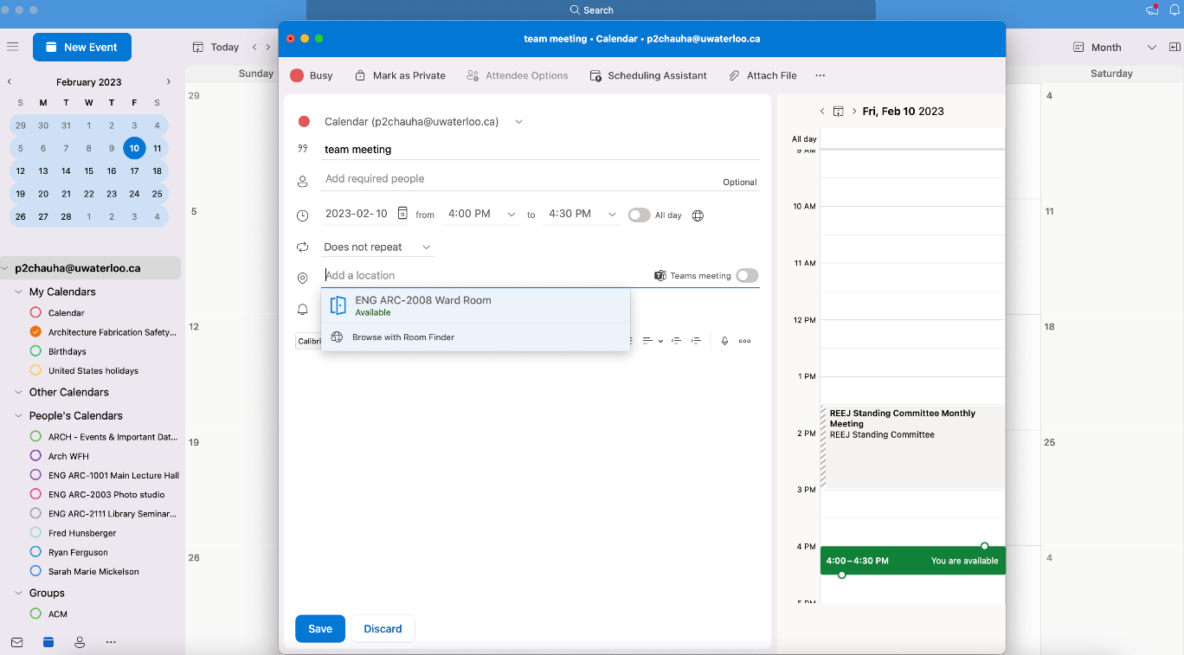

- Filter the room list by selecting city “Cambridge.”

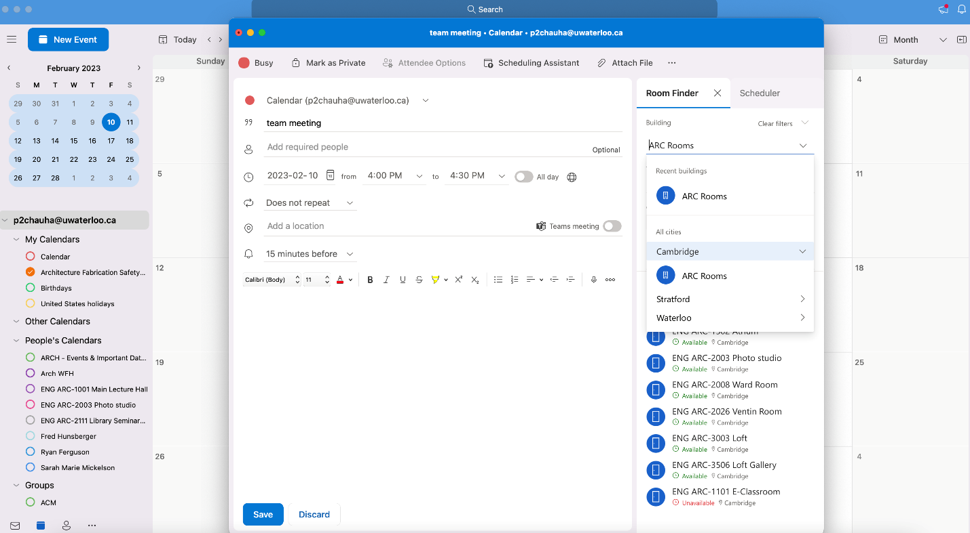

- Double-click the room to add it and click OK, if possible, please mention reason for your booking request.

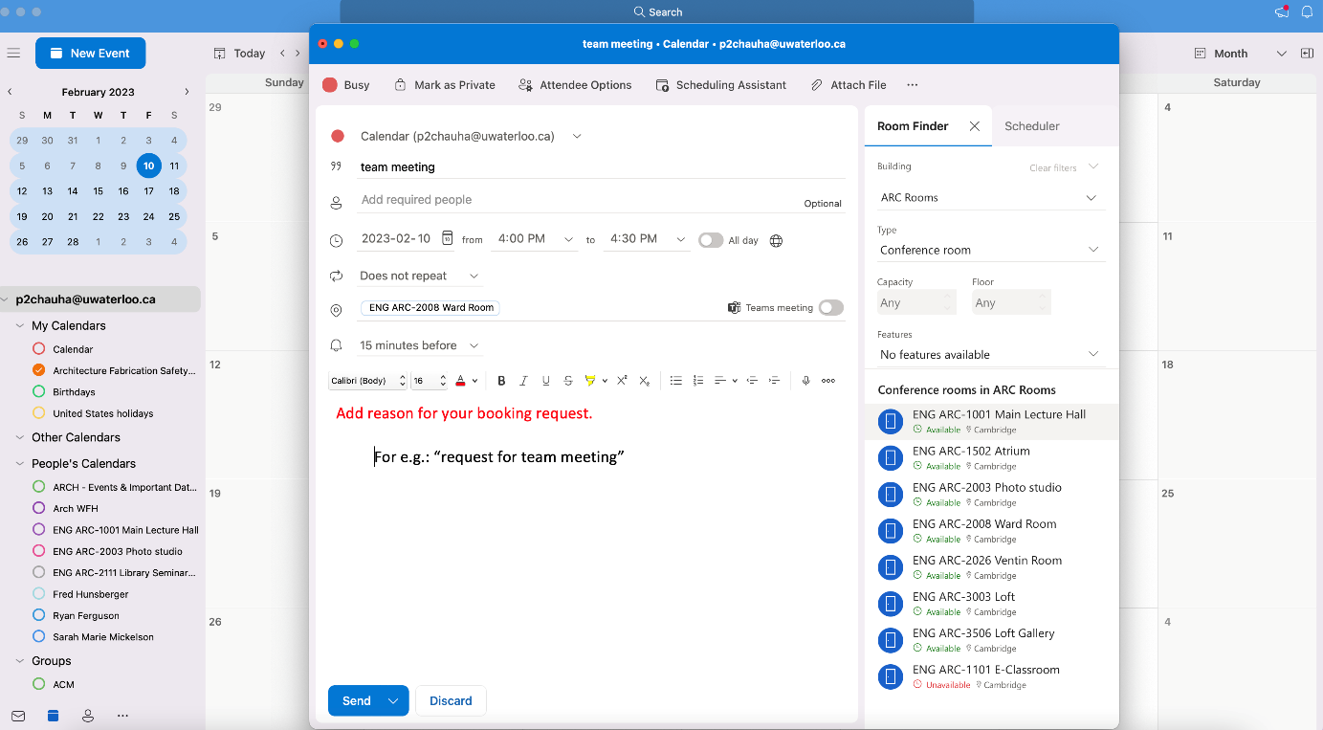

- Your booking request will go to “Administrative Assistance” to approve.
Note: Room requests will be approved or declined based on priorities.

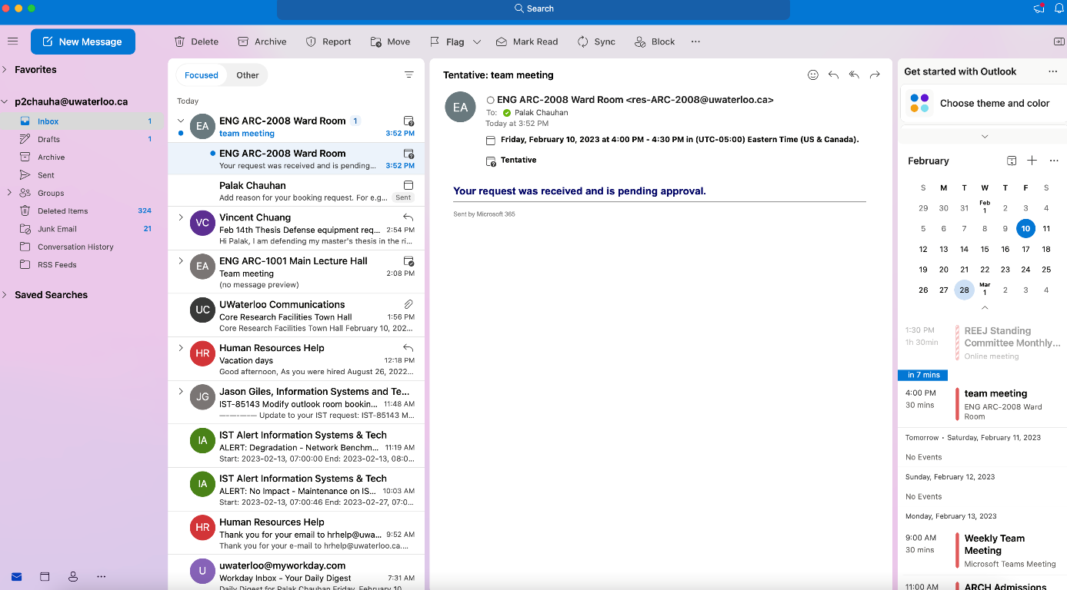

- You will receive email confirmation once the request is approved.

